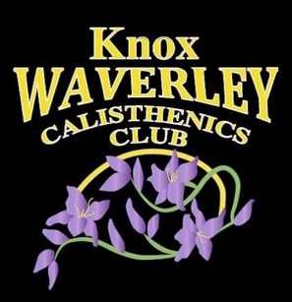
Knox Waverley Calisthenics Club

Member Agreement Policy

- I have read the information booklet and understand the club’s, coaches’, and my obligations under the Knox Waverley Calisthenics Club (KWCC) Policies and Codes of Conduct.

- I also acknowledge that I agree to pay the scheduled fee in full by 30 November of each year. I understand that if my fees are not paid by 30 November, then my child or I will be ineligible for medals and/or trophies as stated on the fee schedule, at the executive committee’s discretion. I also understand that is there are problems with my payment of fees, I can approach the treasurer to discuss this with impartiality. I also agree to sign up to the appointed recurring payment system for regular payments.

- I understand that I/my child must be available to attend and compete in all competitions entered by the club, as well as presentation day and concert day, any absentee to these events must be in writing to the coach or committee ASAP and I/my child agree to abide by all rules and regulations of CV and KWCC at all competitions.

- I understand that if the year is not completed, I am obligated to pay fees as deemed by the treasurer.

- I acknowledge and agree that I/my child will wear the correct KWCC uniform to all competitions, annual concert and any official KWCC event where the KWCC uniform must be worn.

- I/we agree to the terms and conditions of enrolment with Knox Waverley Calisthenics Club.

Signed: (guardian must co-sign for members under 18 years of age)

Parent Signature: _______________________________________________

Parent Full Name: _______________________________________________

Participant Signature: ____________________________________________

Participant Full Name: ____________________________________________

Date: ________________________________________

